Turn on/off Mini-Sync

- Open the OAGIS XA Provider Utility
  - Click on Start Menu to All Programs
  - Open folder Paper-Less XA OAGIS Provider
  - Select OAGIS XA Provider Utility

- Step 1: Select an IIS Web Site Containing XA Provider Virtual Directories
  - Select Default Web Site

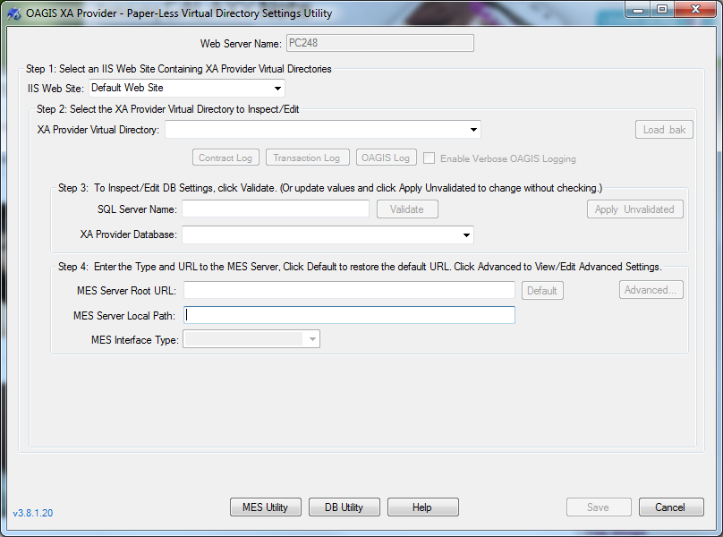

- Step 2: Select the XA Provider Virtual Directory To Inspect/Edit
  - Select PaperLess if you are working with the Production Environment or PaperLess.Test if you are working with the Test Environment
  - The rest of the fields should populate if already configured, if the fields do not populate then that environment is not configured

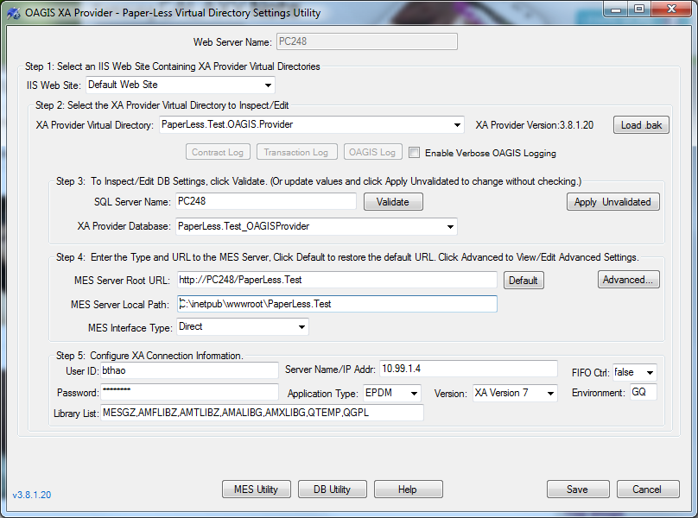

- In Step 4, Click on the Advanced Tab

- Click on Services & Actions Tab located on the top right

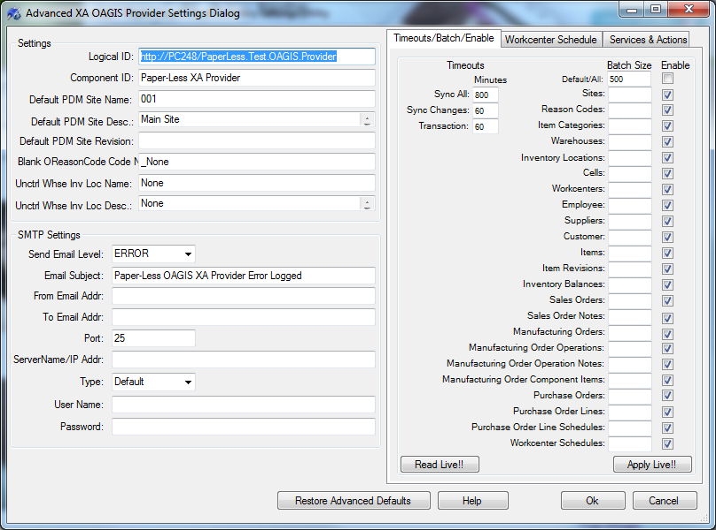

- Make sure that you have the Mini-Sync service enabled for the environment you want to mini-sync in the text box

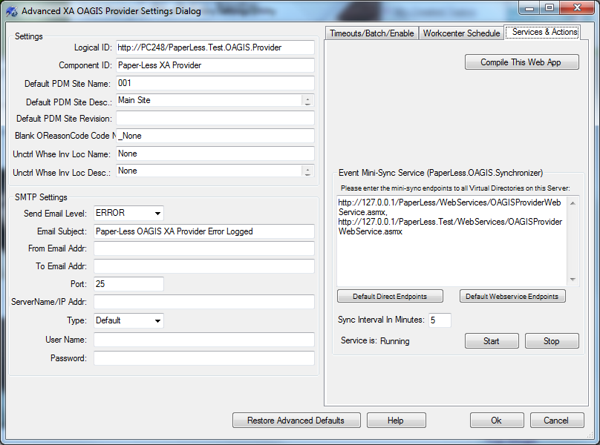
- To start the min-sync service click Start, to Stop the mini-sync click Stop

- To change the mini-sync intervals enter in when you want the mini-sync to occur inside the input box “Sync Interval in Minutes”

